ECOMMERCE SQL QUERY
- BASIC OVERVIEW
1.1 Total number of orders
SELECT COUNT(DISTINCT OrderID) AS Total_Orders
From ecommerce;
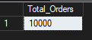
1.2 Total revenue
SELECT SUM(TotalAmount) AS total_revenue
From ecommerce;
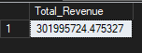
1.3 Average order value
SELECT CAST(AVG(TotalAmount) AS decimal(10,2)) AS avg_order_value
FROM ecommerce;
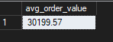
- PRODUCT & CATEGORY ANALYSIS
2.1 Revenue by category
SELECT Category,
SUM(TotalAmount) AS revenue
FROM ecommerce
GROUP BY Category
ORDER BY revenue DESC;
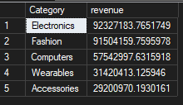
2.2 Top-selling products (by revenue)
SELECT Product,
SUM(TotalAmount) AS revenue
FROM ecommerce
GROUP BY Product
ORDER BY revenue DESC;
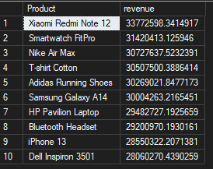
2.3 Products by quantity sold
SELECT Product,
SUM(Quantity) AS total_units
FROM ecommerce
GROUP BY Product
ORDER BY total_units DESC;
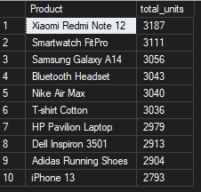

- BRAND & PLATFORM PERFORMANCE
3.1 Platform performance
SELECT Platform,
COUNT(DISTINCT OrderID) AS orders,
SUM(TotalAmount) AS revenue
FROM ecommerce
GROUP BY Platform
ORDER BY revenue DESC;
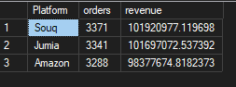
- GEOGRAPHIC ANALYSIS
4.1 Sales by city
SELECT City,
SUM(TotalAmount) AS revenue
FROM ecommerce
GROUP BY City
ORDER BY revenue DESC;
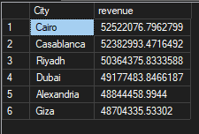
- CUSTOMER FEEDBACK ANALYSIS
5.1 Average rating by product
SELECT Product,
AVG(Rating) AS avg_rating
FROM ecommerce
GROUP BY Product
ORDER BY avg_rating DESC;
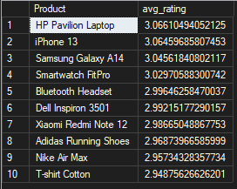
5.2 Reviews vs revenue
SELECT Product,
SUM(Reviews) AS total_reviews,
SUM(TotalAmount) AS revenue
FROM ecommerce
GROUP BY Product;
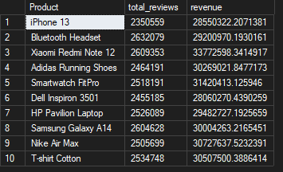
- TIME-BASED ANALYSIS
6.1 Sales by month
SELECT
YEAR(OrderDate) AS year,
MONTH(OrderDate) AS month,
SUM(TotalAmount) AS revenue
FROM ecommerce
GROUP BY YEAR(OrderDate), MONTH(OrderDate)
ORDER BY year, month;
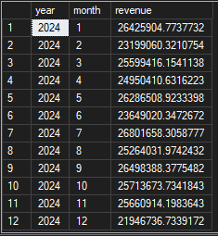

POWER BI – MEASURES (DAX)
Total Revenue
Total Revenue = SUM(ecommerce_10000[TotalAmount])
Total Orders
Total Orders = DISTINCTCOUNT(ecommerce_10000[OrderID])
Total Quantity Sold
Total Quantity = SUM(ecommerce_10000[Quantity])
Average Order Value
Average Order Value =
DIVIDE([Total Revenue],[Total Orders],0)
Average Rating
Average Rating = AVERAGE(ecommerce_10000[Rating])

